Họ và tên:.................................... Lớp 4/....... Ngày 29/4/2020
Test lesson 1-2

1 Write the words.
/ 7
litter playground flowers path grass garbage can trees fountain

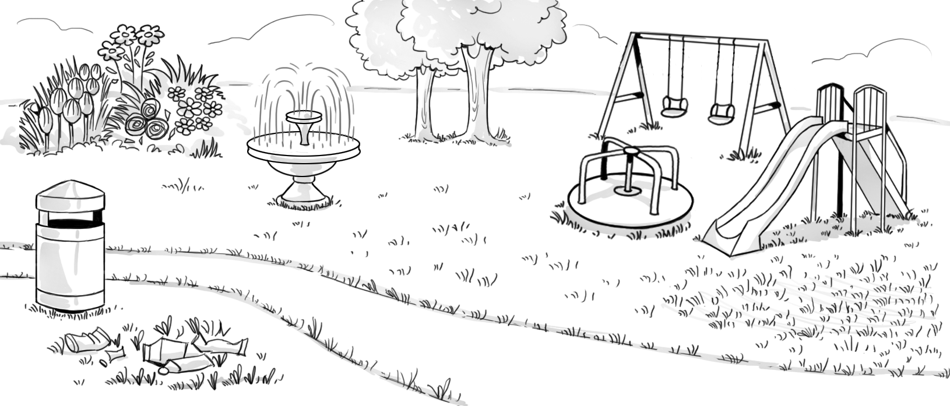  3  8  2  1  6  5  7  4 | 1 flowers  2  3  4  5  6  7  8
2 Look and circle.
1 | 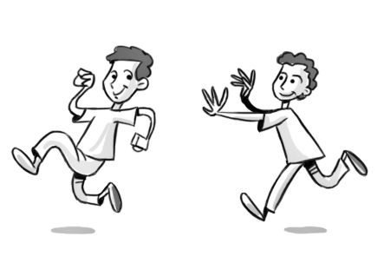 | 2 | 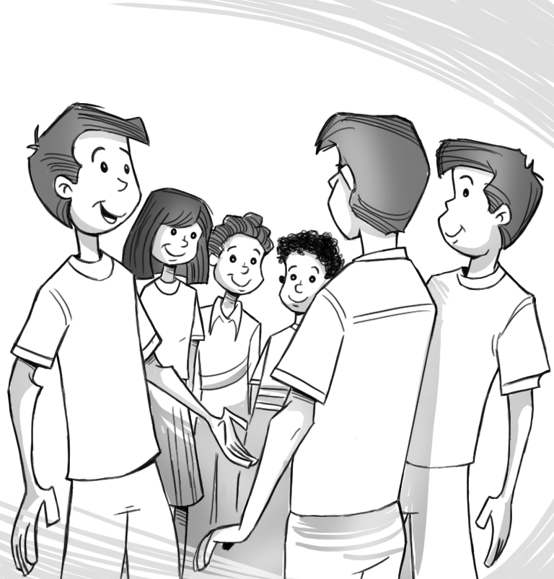 | 3 | 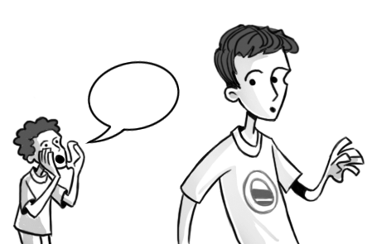 | 4 | 
 | chase / catch |  | meet / cross |  | meet / shout |  | meet / catch
3 Underline the correct words.
/ 3
/ 5
1 | 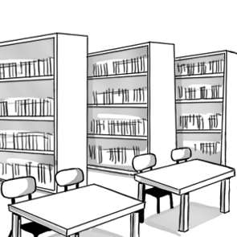 | You must be quiet /  wash your hands /  take photos. | 2 | 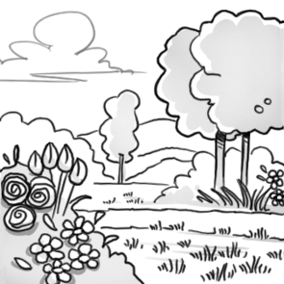 | You mustn’t be quiet /  walk on the flowers /  wash your hands.
3 | 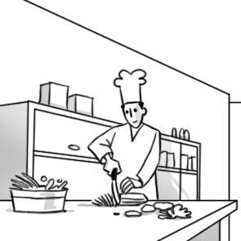 | You must wash your hands / walk your  dog / eat here. | 4 | 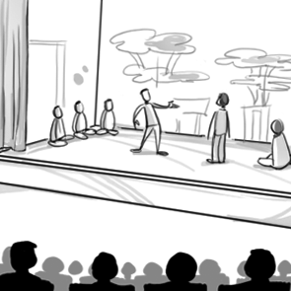 | You mustn’t be quiet / walk on the grass /  take photos.
5 | 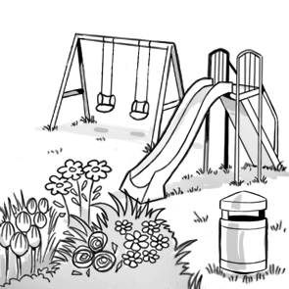 | You mustn’t drop litter / put litter in the garbage can / wash your hands. | 6 | 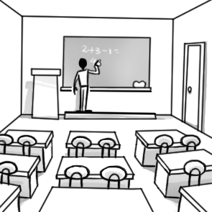 | You mustn’t eat here /  listen to the teacher / walk your dog.

/ 15

